SECTION 1 – HORSES (Alternative Program)


Wondai Show Stockman's Challenge 2026
Open to Any Breed

Competition Information
Date: Saturday, 22 August 2026
Venue: Wondai Showgrounds
All competitors are to be on the grounds by 8:00 am.
Judging commences at 8:30 am sharp.

3 Phase Competition
- Led / Ridden Assessment
- Stock Horse Pattern
- Obstacle Course (Pattern Supplied)

Competition Classes & Entry Fees
Class | Eligibility | Entry Fee
Open | 17 years & Over | $30 per horse
Juvenile | 12–16 years | $30 per horse
Junior | Under 12 years | $20 per horse
Encouragement | Open to Any Age | $20 per horse
Entry fees cover all three phases of competition.

Nominations & Enquiries
Enquiries:
Kathy Donald
Phone: 0418 838 448
Nominations:
Amanda Magee
Email: magee4118@gmail.com
or
Wondai Show Society
PO Box 159
Wondai QLD 4606
Email: secretary@wondaishow.com.au
WONDAI SHOW SOCIETY BANK DETAILS-
BSB- 124 961
A/N- 234 949 81

Judging Conditions
- Stallions and Colts must be handled by competitors in the Open (17 years & Over) class only.
- Geldings, Mares and Fillies of any age are eligible.
- Open, Juvenile, Junior and Encouragement classes will all be judged separately.
- The Led Phase will be judged with all horses together.

Prize Money

Open
Placing | Prize
1st | $100 + Garland
2nd | $60
3rd | $40

Juvenile
Placing | Prize
1st | $50 + Garland
2nd | $30
3rd | $20

Junior
Placing | Prize
1st | $25 + Garland
2nd | $15
3rd | $10

Encouragement
Placing | Prize
1st | $25 + Garland
2nd | $15
3rd | $10
Ribbons awarded to 1st, 2nd and 3rd place in each class.
Points earned throughout the competition count towards the Final Rounds.

Champion Awards
Champion and Reserve Champion will be awarded in each class.

Senior Supreme Champion
Dan Retschlag Memorial Trophy
• Trophy donated by the Retschlag Family
• Supreme Ribbon
• Champion Rug donated by Gympie Saddleworld

Junior Supreme Champion
Kim & Sonia Afford Trophy
• Trophy donated by Kim & Sonia Afford
• Supreme Ribbon
• Champion Rug donated by Gympie Saddleworld

Lucky Participant Draw
Every competitor will automatically go into the draw to win a $40 Carney's Feed Store Voucher.
Winner drawn at the completion of the competition.

WONDAI SHOW SOCIETY INC.
2026 WONDAI SHOW STOCKMAN'S CHALLENGE
NOMINATION FORM
All competitors must be on the grounds by 8:00 am.
Judging commences at 8:30 am sharp.
Competitor Details
Competitor Name: _________________________________________________
Address: _________________________________________________
Suburb: _________________________________________________
State: _________________________________________________
Postcode: _________________________________________________
Phone: _________________________________________________
Email: _________________________________________________
Date of Birth (if under 18): _________________________________________________
Emergency Contact: _________________________________________________
Emergency Contact Phone: _________________________________________________
Horse Details
Horse Name: _________________________________________________
Breed: _________________________________________________
Age: _________________________________________________
Sex (Circle): Gelding / Mare / Filly / Stallion / Colt _________________________________________________
Registered Name (if applicable): _________________________________________________
Competition Class
☐ Open (17 Years & Over) – $30
☐ Juvenile (12–16 Years) – $30
☐ Junior (Under 12 Years) – $20
☐ Encouragement (Open to Any Age) – $20
Declaration
I agree to compete entirely at my own risk, abide by the rules of the Wondai Show Society, declare my horse is fit to compete, acknowledge the Judge's decision is final, and release the Society from liability for injury, loss or damage.
Competitor Signature: _________________________________________________
Date: _________________________________________________
Parent/Guardian Consent (Under 18 Years)
I give permission for the above competitor to compete.
Parent/Guardian Name: _________________________________________________
Signature: _________________________________________________
Phone: _________________________________________________
Office Use Only
Nomination Received | ☐ Yes ☐ No
Entry Fee Paid | ☐ Cash ☐ EFT ☐ Other
Amount Paid | $
Competitor Number
Class
Nomination Information
Enquiries
Kathy Donald
0418 838 448

Nominations
Amanda Magee
magee4118@gmail.com
Wondai Show Society
PO Box 159
Wondai QLD 4606
secretary@wondaishow.com.au

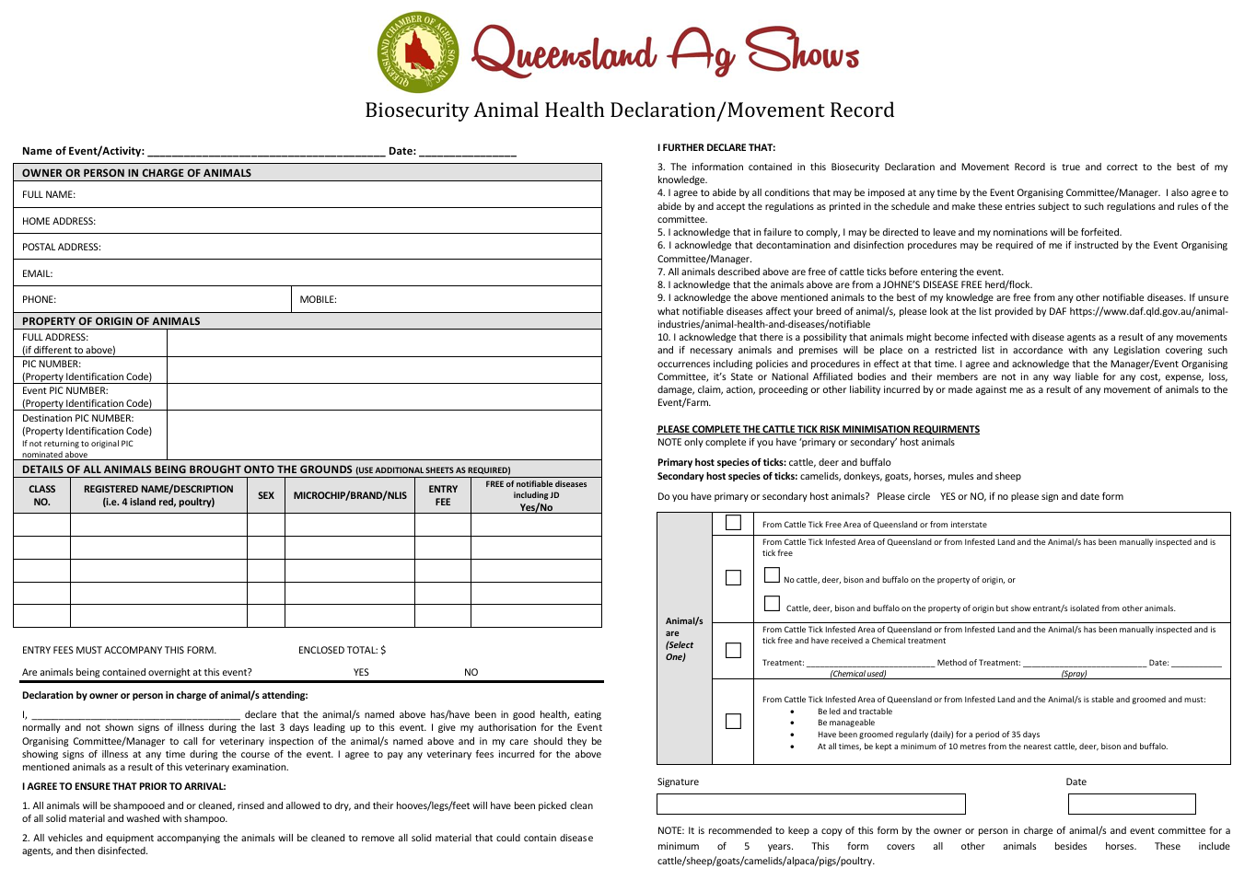
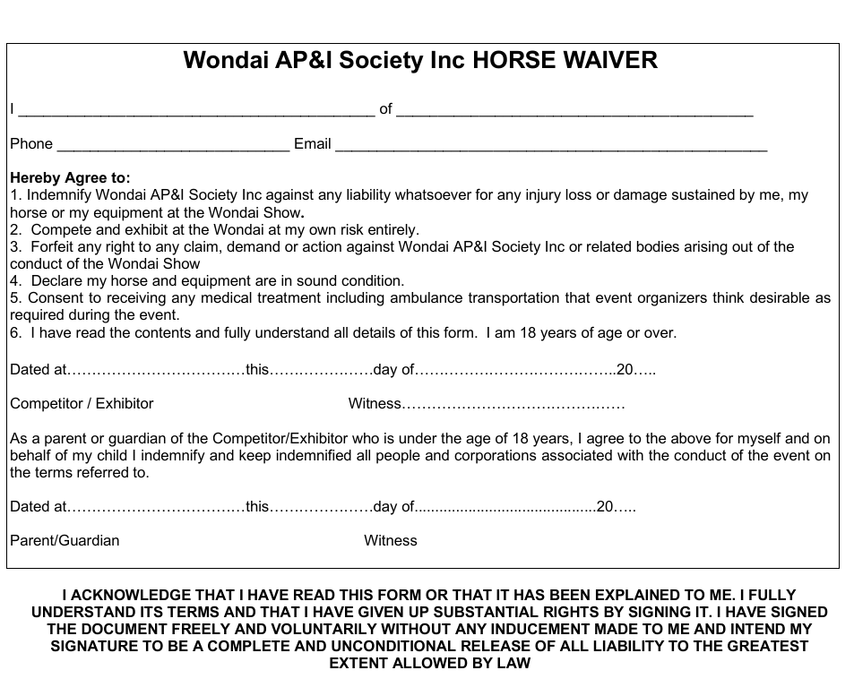

Thank You to the Sponsors of the Wondai Show Stockman’s Challenge



Kathy & Darren Donald – Crowned Acres Oak Performance Horses
Retschlag Family – In Memory of Dan Retschlag
Kim & Sonia Afford – Afford Racing
Sue Hullock & Family

