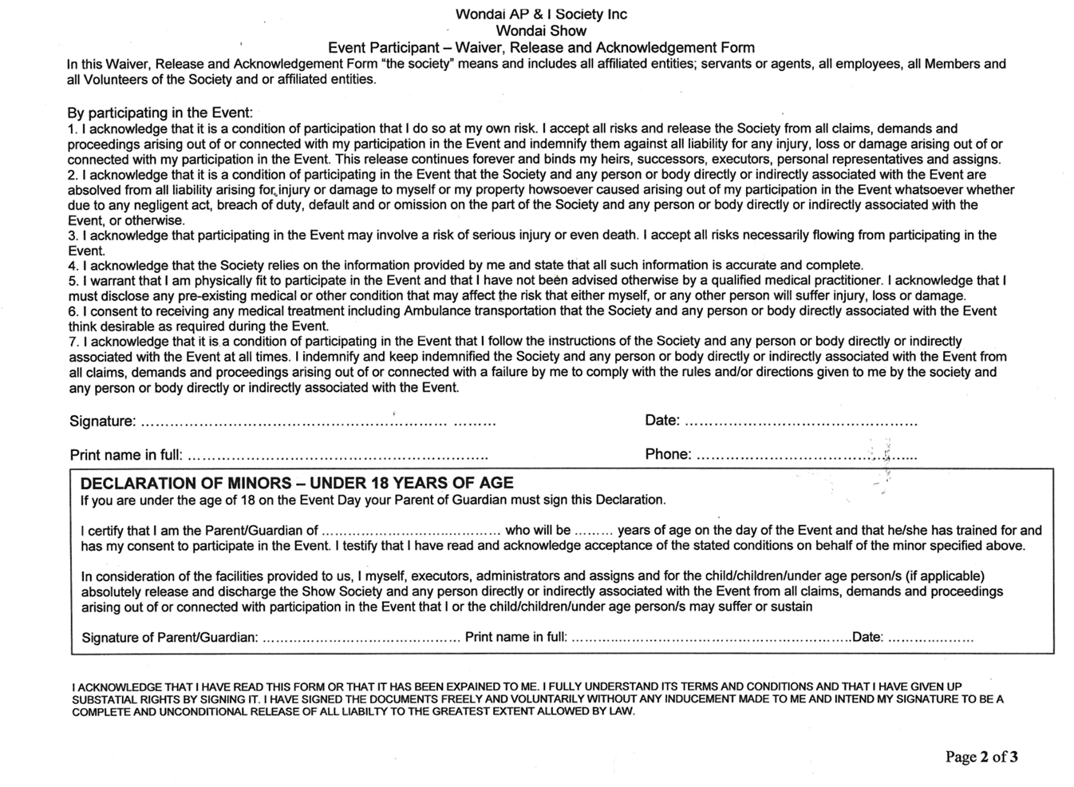
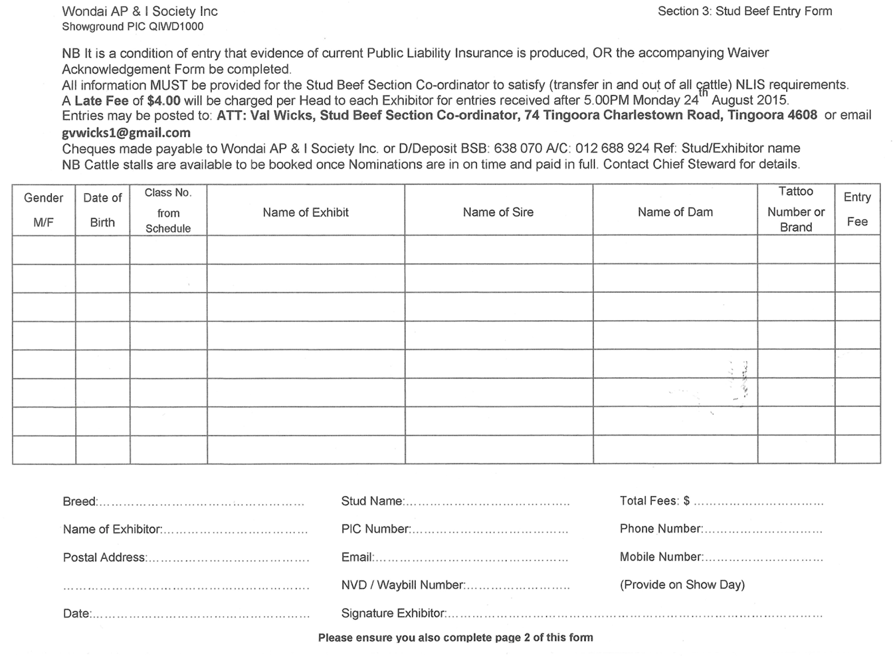
2349 4981
124 961
OR EMAIL jasminefirmin98@gmail.com
ATTENTION: JASMINE THORNES, CATTLE STEWARD- PO BOX 159, WONDAI. QLD 4606

18TH AUGUST 2025

