Celebrating its 104th Show

Horses  Included:  Horse Classes  Horse Declaration Form  Equestrian Waiver  Camping & Stabling Form | Saturday, 2nd September  2023
For further information, please contact the Steward listed in the programme
or the Show Secretary:
Post: PO Box 159, Wondai 4606
Phone: 0427 685 171
Email: secretary@wondaishow.com.au
Camping on Friday & Saturday nights – free but unpowered sites only available

Check the show website (www.wondaishow.com.au) & Facebook page for up-to-date information on the 2023 Show.

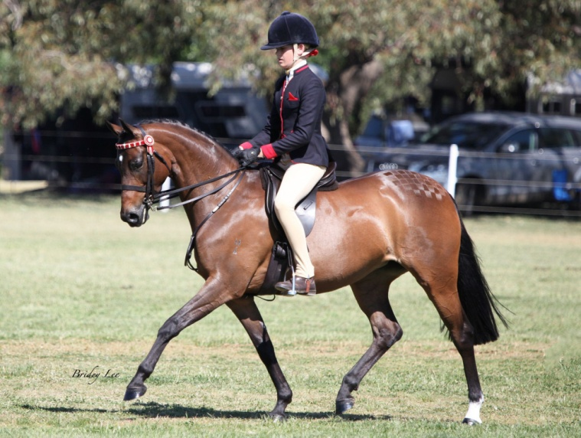
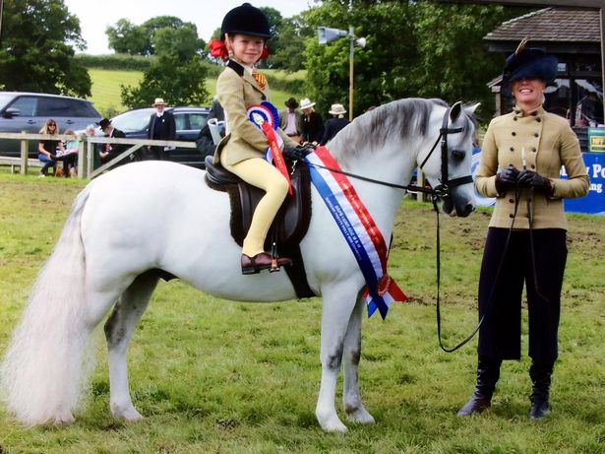

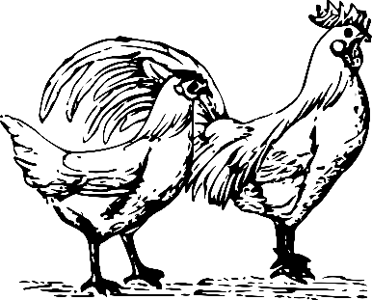
HORSE SECTION

CHIEF RING STEWARDS: DAVID PITSTOCK Mobile: 0427 169 043
Email: secretary@wondaishow.com.au

Rules and Regulations
- ALL EXHIBITORS MUST PAY THE GATE FEE ON ENTRY TO THE GROUNDS
- Stables MUST be pre booked (Form on website or contact the Chief Ring Steward)
- Hacks, Galloways & Ponies may be measured Saturday. (8.00 am to 8.30 am)
- The following DEFINITIONS and CONDITIONS shall apply:
PONY - Not exceeding 14 hands
GALLOWAY - Over 14 hands and not exceeding 15 hands
HACK - Over 15 hands
MAIDEN - A horse that has not won a first prize at an Agricultural Show excluding
local and district classes
- In the event of a dispute, the Rules of the Queensland Chamber of Agricultural Societies shall apply. A protest must be lodged at the secretary’s office in writing with a bond of $100.00 no later than 1 hour after the judging of the event in which the protest is to be made. The bond will be forfeited if the protest is turned down and refunded if the protest is upheld
- All competitors compete at their own risk
- All stallions and colts 1 year and over must be lead or ridden by a person 18 years or over
- Any prize not claimed during the show will be forfeited to the society
- Registration certificates & membership cards must be produced on request to the Judge in all classes
- The Judge shall withhold any prize ribbon when the exhibit is not of sufficient merit
- Exhibitors entered in the wrong classes may be transferred to the correct class at the discretion of the Chief Ring Steward
- The Society reserves the right to substitute special prizes which may be donated later for any advertised schedule prizes
- The Society reserves the right to amend the schedule at any time
- District events are restricted to the residents of the South Burnett Regional Council area
- The show hunter classes are supported by the Australian Hunter Horse Association (AHHA). Wondai show 2022 is an AHHA Show National Qualifier. You MUST be a financial member to compete in the AHHA classes
- Horses/ponies and handlers competing in the Restricted Ring may not compete in the Open breed/hack/hunter rings (except in classes as indicated).
- All competitors must sign the Indemnity Forms & Horse Health Declarations to enable entry into classes - parents or guardians to sign for competitors under 18 years of age
- PONIES may be ridden by adults
MURGON
NOTE: Horses may compete as EITHER Ridden Show Hacks or Ridden Hunters

BREED & OPEN CLASSES - RINGS 1, 2 & 4
ENTRY FEE: $3.00 per entry
PRIZE MONEY: 1st $10, 2nd $5, 3rd $3.00
RESTRICTED RING 3
ENTRY FEE: $2.00 per entry
PRIZE MONEY: 1st $4, 2nd $3, 3rd $2

7
RING 4
ENTRY FEE: $3.00 per entry
PRIZE MONEY: 1st $10, 2nd $5, 3rd $2

RESTRICTED CLASSES – RING 3
ENTRY FEE: $2.00 per entry
PRIZE MONEY: 1st $4, 2nd $3, 3rd $2

RING 1 - START TIME: 8.30 am

THOROUGHBRED
      - Colt/Stallion
      - Filly/Mare
      - Gelding any age
CHAMPION THOROUGHBRED - Sash & $30 sponsored by HITCHLEY & HARROW
RESERVE CHAMPION – Sash & $20 sponsored by HITCHLEY & HARROW
A.N.S.A.
      - Colt/Stallion
      - Filly/Mare
      - Gelding any age
CHAMPION A.N.S.A. - Sash & $30 sponsored by HITCHLEY & HARROW
RESERVE CHAMPION – Sash & $20 sponsored by HITCHLEY & HARROW
QUARTERHORSE
      - Colt/Stallion
      - Filly/Mare
      - Gelding any age
CHAMPION QUARTERHORSE - Sash & $30 sponsored by HITCHLEY & HARROW
RESERVE CHAMPION – Sash & $20 sponsored by HITCHLEY & HARROW
STANDARDBRED
      - Colt/Stallion
      - Filly/Mare
      - Gelding any age
CHAMPION STANDARDBRED - Sash & Bale Hay Donated by YeeHaa Hay Farm, G & A Palmer
RESERVE CHAMPION – Sash & Bale Hay Donated by YeeHaa Hay Farm, G & A Palmer

AUSTRALIAN STOCK HORSE
      - Colt/Stallion
      - Filly/Mare
      - Gelding any age
CHAMPION AUST STOCK HORSE - Sash & $30 sponsored by HITCHLEY & HARROW
RESERVE CHAMPION – Sash & $20 sponsored by HITCHLEY & HARROW

DILUTE HORSE (Buckskin, Palomino, White Horses any height)
      - Colt/Stallion
      - Filly/Mare
      - Gelding any age
CHAMPION DILUTE HORSE- Sash & Bale Hay Donated by YeeHaa Hay Farm, G & A Palmer
RESERVE CHAMPION – Sash & Bale Hay Donated by YeeHaa Hay Farm, G & A Palmer

ANY OTHER BREED (OVER 14HH
      - Colt/Stallion
      - Filly/Mare
      - Gelding any age
CHAMPION ANY OTHER BREED – Sash & Bale Hay Donated by YeeHaa Hay Farm, G & A Palmer
RESERVE CHAMPION – Sash & Bale Hay Donated by YeeHaa Hay Farm, G & A Palmer

HEAVY HORSE – ANY BREED
      - Colt/Stallion
      - Filly/Mare
      - Gelding any age
CHAMPION HEAVY HORSE. - Sash & Bale Hay Donated by YeeHaa Hay Farm, G & A Palmer
RESERVE CHAMPION - Sash& Bale Hay Donated by YeeHaa Hay Farm, G & A Palmer
SUPREME LED OF THE SHOW
$50 donated by Cheryl Dunstan
Prize Donated by SAP KREATIONS
Garland Donated by JILL KEATES

RIDDEN BREED CLASSES
- Ridden Thoroughbred
- Ridden Standardbred
- Ridden Any Other Breed
- Ridden Heavy Horse

RIDDEN SHOW HACK
29. Maiden Hack
30. Novice Hack
31. District Hack
32. Open Hack 15hh ne 16hh
33. Open Hack over 16hh
CHAMPION SHOW HACK (Classes 29 - 33) – Sash & Bag of Pony Pellets donated by Norco Kingaroy
RESERVE CHAMPION – Sash & Bale Hay Donated by YeeHaa Hay Farm, G & A Palmer
RIDDEN SHOW GALLOWAY
34. Maiden Galloway Hack
35. Novice Galloway Hack
36. District Galloway Hack
37. Open Galloway Hack, 14hh ne 14.2hh
38. Open Galloway Hack, over 14.2hh & ne 15hh
CHAMPION GALLOWAY HACK (Classes 34 - 38) - Sash & Bag of Pony Pellets donated by Norco Kingaroy
RESERVE CHAMPION – Sash & Bale Hay Donated by YeeHaa Hay Farm, G & A Palmer
BRIAN KEMP MEMORIAL CHAMPION GALLOWAY HACK
Prize Donated by Cr KATHY DUFF

RIDDEN SHOW HUNTER HACK
39. Maiden Hunter Hack
40. Novice Hunter Hack
41. District Hunter Hack
42. Open Hunter Hack, over 15hh ne 16hh
43. Open Hunter Hack, over 16hh
44. AHHA Show Hunter Hack
CHAMPION SHOW HUNTER HACK (Classes 39 - 44) - Sash & Bag of Pony Pellets donated by Norco Kingaroy
RESERVE CHAMPION – Sash & Bale Hay Donated by YeeHaa Hay Farm, G & A Palmer
RIDDEN SHOW HUNTER GALLOWAY
45. Maiden Galloway Hunter
46. Novice Galloway Hunter
47. District Galloway Hunter
48. Open Galloway Hunter, 14hh ne 14.2hh
49. Open Galloway Hunter, over 14.2hh ne 15hh
50. AHHA Show Hunter Hack
CHAMPION HUNTER GALLOWAY (Classes 45 - 50 ) Sash & Bag of Pony Pellets donated by Norco Kingaroy
RESERVE CHAMPION – Sash & Bale Hay Donated by YeeHaa Hay Farm, G & A Palmer
SUPREME HACK OF SHOW
$50 donated by Cheryl Dunstan
Prize Donated by SAP KREATIONS Garland Donated by LES’S HANDYMAN SERVICES

SUPREME HUNTER OF SHOW
$50 donated by GLENIS MILLER
Garland Donated by LES’S HANDYMAN SERVICES

ADULT RIDER CLASSES
51. Gent or Lady Rider over 17 years & under 21 years
52. Gent or Lady Rider 21 years & over
CHAMPION Adult Rider Sash & Bag of Pony Pellets donated by Norco Kingaroy
RESERVE CHAMPION Sash & Bale of Hay donate by YeeHaa Hay Farm, G & A Palmer

HEAVY HORSE WORKING CLASSES
Open to any heavy horse including not registered. All horses to be driven in long reins, winkers,
collar, hames, backband and chains.
Slide and swingle bar will be provided
53. Driven in long reins
54. Slide obstacle course
55. Log snig
56. Pumpkin Snatch
CH WORKING HEAVY HORSE (Classes 53 – 56) Sash & Bag of Pony Pellets donated by Norco Kingaroy
RESERVE CHAMPION Sash & Bale of Hay donate by YeeHaa Hay Farm, G & A Palmer
HARNESS CLASSES
57. Pony turnout
58. Light horse turnout
59. Heavy horse turnout
60. Pony in Harness
61. Light horse in Harness
62. Heavy Horse in Harness
63. Lady Whip
64. Gentleman Whip
65. Junior Whip – 17 years and under
CHAMPION HARNESS CLASSES 57 - 65 – Sash & Bag of Pony Pellets donated by Norco Kingaroy RESERVE CHAMPION Sash & Bale of Hay donate by YeeHaa Hay Farm, G & A Palmer

RING 2 - START TIME: 8.30am

WELSH PONIES (Part Welsh included)
66. Colt/Stallion
67. Filly/Mare
68. Gelding any age
CHAMPION WELSH - Sash & Bale Hay Donated by YeeHaa Hay Farm, G & A Palmer
RESERVE CHAMPION – Sash & Bale Hay Donated by YeeHaa Hay Farm, G & A Palmer
AUSTRALIAN SADDLE PONY
69. Colt/Stallion
70. Filly/mare
71. Gelding any age
CHAMPION ASP - Sash & Bale Hay Donated by YeeHaa Hay Farm, G & A Palmer
RESERVE CHAMPION – Sash & Bale Hay Donated by YeeHaa Hay Farm, G & A Palmer
AUSTRALIAN RIDING PONY
72. Colt/Stallion
73. Filly/mare
74. Gelding any age
CHAMPION ARP - Sash & Bale Hay Donated by YeeHaa Hay Farm, G & A Palmer
RESERVE CHAMPION – Sash & Bale Hay Donated by YeeHaa Hay Farm, G & A Palmer
ARABIANS (Purebreds & Derivatives any height)
75. Colt/Stallion
76. Filly/Mare
77. Gelding any age
CHAMPION ARABIAN - Sash & Bale Hay Donated by YeeHaa Hay Farm, G & A Palmer
RESERVE CHAMPION – Sash & Bale Hay Donated by YeeHaa Hay Farm, G & A Palmer
ANY OTHER BREED PONY (ne 14hh)
78. Colt/Stallion
79. Filly/Mare
80. Gelding any age
CHAMPION ANY OTHER BREED ne 14hh - Sash & Bale Hay Donated by YeeHaa Hay Farm, G & A Palmer
RESERVE CHAMPION – Sash & Bale Hay Donated by YeeHaa Hay Farm, G & A Palmer

SUPREME LED OF THE SHOW
Prize Donated by SP KREATIONS
Garland Donated by LES’S HANDYMAN SERVICE

RIDDEN BREED CLASSES
81. Ridden Welsh (Part Welsh included)
82. Ridden Australian Saddle Pony
83. Ridden Australian Riding Pony
84. Ridden Arabian/Derivative
85. Ridden Any Other Breed, ne 14hh

RIDDEN SHOW PONIES
86. Maiden Pony Hack
87. Novice Pony Hack
88. Childs Pony Hack
89. District Pony Hack
90. Open Pony Hack ne 13hh
91. Open Pony Hack over 13hh & ne 14hh
CHAMPION PONY HACK (Classes 86 - 91) - Sash & Bag of Pony Pellets donated by Norco Kingaroy
RESERVE CHAMPION- Sash

RIDDEN SHOW HUNTER PONIES
92. Maiden Pony Hunter
93. Novice Pony Hunter
94. Child Pony Hunter
95. District Pony Hunter
96. Open Pony Hunter, ne 13hh
97. Open Pony Hunter, over 13hh ne 14hh
98. AHHA Show Hunter Pony
CHAMPION PONY HUNTER (Classes 92-98) - Sash & Bag of Pony Pellets donated by Norco Kingaroy RESERVE CHAMPION - Sash
SUPREME HACK OF SHOW
$50 Prize donated by CHERYL DUNSTAN
Prize Donated by SP KREATIONS
Garland Donated by LES’S HANDYMAN SERVICE

SUPREME HUNTER OF SHOW
$50.00 donated by Glenis Miller
Garland Donated by LES’S HANDYMAN SERVICE

JUNIOR RIDER CLASSES
99. Boy or Girl Rider 8 years and under
100. Boy or Girl Rider 9 years and under 12 years
CHAMPION & RESERVE CHAMPION JUNIOR RIDER - Sash & Trophy
INTERMEDIATE RIDER CLASSES
101. Boy or Girl Rider over 12 years and under 15 years
103. Boy or Girl Rider 15 years and under 17 years
CHAMPION & RESERVE CHAMPION INTERMEDIATE RIDER - Sash & Trophy

RING 3 - START TIME: 8.30am
RESTRICTED CLASSES (IN THE ENCLOSED SAND ARENA)
LED CLASSES
104. Best Presented Handler under 8 Years (horse to be led)
105. Best Presented Handler 8 years & over (horse to be led)
106. Led Pony
107. Led Galloway/Hack (over 14h)

RIDDEN CLASSES
108. Maiden Pony Hack/Hunter
109. Maiden Galloway Hack/Hunter
110. Maiden Hack/Hunter
111. Novice Pony Hack/Hunter
112. Novice Galloway Hack/Hunter
113. Novice Hack/Hunter
114. Open Pony Hack/Hunter
115. Open Galloway Hack/Hunter
116. Open Hack/Hunter

CHAMPION & RESERVE CHAMPION PONY, GALLOWAY, OR HACK (Classes 108 - 116)
CHAMPION TROPHY donated by DEB FRECKLINGTON MP,
SASH & BAG OF HORSE FEED DONATED BY RIVERINA STOCKFEED
RESERVE CHAMPION TROPHY
SASH & BAG OF HORSE FEED donated by RIVERINA STOCKFEED

RIDER CLASSES
117. Rider any age - to be led
118. Rider under 8 years
119. Rider 8 years & under 12 years
120. Rider 12 years & under 16 years
121. Rider 16 years and over
CHAMPION & RESERVE CHAMPION LADY, GENT, GIRL OR BOY RIDER (Classes 117 - 121)

CHAMPION TROPHY donated by DEB FRECKLINGTON MP,
TROPHY SASH & BAG OF HORSE FEED
Donated by RIVERINA STOCKFEED
RESERVE CHAMPION TROPHY SASH & BAG OF HORSE FEED donated by RIVERINA STOCKFEED

Bev Pickels Encouragement Award
$25 Prize Donated by KATHY DUFF & Trophy
To be chosen by the Judge for the most improved handler/rider

BEV PICKLES ENCOURAGEMENT AWARD
TROPHY & $25 PRIZE donated by KATHY DUFF
To be chosen by the Judge
for the most improved handler/rider

RING 4 - START TIME: 8.30am
Miniature, Small, Little Horses and Ponies
To be judged under the guidelines and rules of the Australian Miniature Horse and Pony Registry
Entry Fee - $3.00 First - $10.00, Second - $5.00, Third - $2.00
LED CLASSES
MINIATURE HORSE
122. Colt/Gelding 2 years and under
123. Gelding 3yrs and over
124. Filly 2 yrs and under
125. Mare/Filly 3 yrs and over
126. Colt/Stallion any age

CHAMPION MINIATURE HORSE - Sash, Rosette & bale of Hay
RESERVE CHAMPION - - Sash & bale of Hay
SMALL/LITTLE HORSE
127. Gelding 2 years and under
128. Gelding 3 years and over
129. Filly 2 years and under
130. Mare/Filly 3 years and over
131. Colt/Stallion any age

CHAMPION SMALL HORSE- Sash, Rosette & bale of Hay
RESERVE CHAMPION - Sash & bale of Hay
MINIATURE/SMALL PONY
132.Gelding 2 years and under
133. Gelding 3 years and over
134. Filly 2 years and under
135. Mare/Filly 3 years and over
136. Colt/Stallion any age
CHAMPION MINIATURE /SMALL PONY - Sash, Rosette & bale of Hay
RESRVE CHAMPION - Sash & bale of Hay
SHETLAND PONY
137. Gelding any age
138. Mare/Filly any age
139. Colt/Stallion any age

CHAMPION SHETLAND PONY - - Sash, Rosette & bale of Hay
RESERVE CHAMPION - - Sash & bale of Hay

SUPREME CHAMPION MINIATURE/SMALL/LITTLE PONY
$25 donated by Water View Park Miniatures
SASH, RUG & GARLAND

SUPREME CHAMPION MINIATURE/SMALL/SHETLAND PONY
$25 donated by Water View Park Miniatures
SASH, RUG & GARLAND

SPECIAL NEEDS CLASSES.
Prize money for the 5 Special Needs Classes has been donated by Pauline Keates
140. Best Presented Horse/Pony/Handler 141. Led Horse/Pony
142. Best Classic Trot 143. Trail
144. Hunter
CHAMPION SPECIAL NEEDS AWARD – Trophy donated by Water View Park Miniatures
Sash, Garland & bale of Hay
RESERVE CHAMPION - Sash & bale of Hay
All other competitors - Rosette
NOVELTY CLASSES
145. Best Classic Head Miniature/Small/Little Horse
146. Best Classic Head Miniature/Small/Little Pony
147. Best Mane and Tail Miniature/Small/Little Horse or Pony
148. Best Colour Miniature/Small/Little Horse or Pony
149. Best Classic Trot Small/Little Horse
150. Best Classic Trot Small/Little Horse
151. Best Classic Trot Miniature/Small Pony
152. Owners Group of two Miniature/Small/Little Horses or Ponies
153. Best Matched Pair

PERFORMANACE - Points will be allocated for each horse's workout in classes 136 to 147, which will be totalled at the finish of the performance for the Championship and place getters of each age group.
Prize Money for the Performance Classes donated by Heatherdoon Miniatures.
154. Youth Trail - 12 years and under
155. Youth Trail - 13 years to 17 years
156. Youth Hunter – 12 years and under
157. Youth Hunter - 13 years to 17 years
158. Open Trail - Miniature/Small/Little Horse 2yrs & Under
159. Open Trail - Miniature/Small/Little Horse 3yrs & Over
160. Open Trail - Miniature/Small/Pony 2yrs & Under
161. Open Trail - Miniature/Small/Pony 3yrs & Over
162. Open Hunter - Miniature/Small/Little Horse 2yrs & Under
163. Open Hunter - Miniature/Small/Little Horse 3yrs & Over
164. Open Hunter - Miniature/Small/Pony 2yrs & Under
165. Open Hunter - Miniature/Small/Pony 3yrs & Over

CHAMPION PERFORMANCE 12 YEARS AND UNDER - Sash and a Bale of Hay
RESERVE CHAMPION – Sash & Bale of Hay
CHAMPION PERFORMANCE 13 Years to 17 Years - Sash and a Bale of Hay
RESERVE CHAMPION – Sash & Bale of Hay
CHAMPION PERFORMANCE Miniature/Small/Little Horse 2yrs & Under
- Sash and a Bale of Hay
RESERVE CHAMPION – Sash & Bale of Hay
CHAMPION PERFORMANCE Miniature/Small/Little Horse 3yrs & Over
Sash and a Bale of Hay
RESERVE CHAMPION – Sash & Bale of Hay
CHAMPION PERFORMANCE Miniature/Small/Pony 2yrs & Under
- Sash and a Bale of Hay
RESERVE CHAMPION – Sash & Bale of Hay
CHAMPION PERFORMANCE Miniature/Small/Pony 3yrs & Over
- Sash and a Bale of Hay
RESERVE CHAMPION – Sash & Bale of Hay

SHOW JUMPING MINIATURE HORSE OR PONY
166. Show Jumping - 17 years and under
167. Show Jumping - 18 years and over
168. Fault & Out – 17 years and under
169. Fault & Out – 18 years and over

CHAMPION SHOWJUMPER 17 YEARS AND UNDER - Sash and a Bale of Hay
RESERVE CHAMPION – Sash & Bale of Hay
CHAMPION SHOWJUMPER 18 YEARS and Over - Sash and a Bale of Hay
RESERVE CHAMPION – Sash & Bale of Hay

ALL GARLANDS, ROSETTES AND RUG
DONATED BY JILL KEATES, HEATHERDOON MINIATURES, WONDAI QLD
Prize Money for both Supreme Horse & Supreme Pony, and Trophy for Special Needs Champion donated by Max & Cheryl McCormick WATERVIEW PARK MINIATURES
Prize Money for Special Needs Classes donated by Pauline Keates

ALL BAGS OF FEED DONATED BY RIVERINA STOCK FEEDS, KINGAROY & NORCO KINGAROY
ALL BALES OF HAY DONATED BY GREG & AMANDA PALMER, YEEHAA HAY FARM, BYEE , WONDAI

SPONSORS
YeeHaa Hay Farm (G & A Palmer) ,Riverina Stockfeeds, Kewpie Stockfeeds, Norco Kingaroy, Ros Heit,
Hitchley & Harrow Toowoomba, Cr Kathy Duff, Deb Frecklington MP. Cheryl Dunstan, Glenis Miller, Wondai Accounting & Tax, Heatherdoon Stud Wondai &Pauline Keates

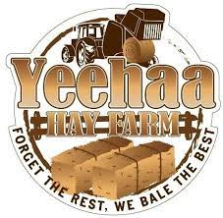

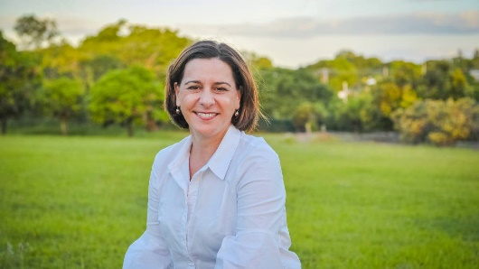

2023 WONDAI SHOW – HORSE SECTION
CAMPING & STABLING

All Campers must have own power for Friday & Saturday nights.
Camping – free for 2 nights of Show; then $15 per vehicle per night (Car & float/gooseneck is counted as 1 unit)

Cheques payable to Wondai A P & I Society Inc.
Direct deposit can be made to:
Account Name: Wondai A P & I Society Inc
BSB- 633000 Account- 1593 52418
Reference your last name followed by the word ‘horses’

Extra Camping Yes

No

No. of units

No. of nights

Stabling - free for the duration of the Show

No. of stables

Please indicate the sex of the horses being stabled.

Mares/Fillies

Geldings

Stallions/Colts

Send your bookings to Lorraine Retschlag
PO Box 159 Wondai QLD 4606
or email: secretary@wondaishow.com.au

EQUESTRIAN WAIVER

Wondai AP&I Society Inc
I _____________________________ of ___________________________________________

Phone _______________________ Fax _______________ Email ______________________

Hereby Agree to:
1. Indemnify Wondai AP&I Society Inc against any liability whatsoever for any injury loss or damage sustained by me, my horse or my equipment at the Wondai Show.
2. Compete and exhibit at the Wondai at my own risk entirely.
3. Forfeit any right to any claim, demand or action against Wondai AP&I Society Inc or related bodies arising out of the conduct of the Wondai Show
4. Declare my horse and equipment are in sound condition.
5. Consent to receiving any medical treatment including ambulance transportation that event organizers think desirable as required during the event.
6. I have read the contents and fully understand all details of this form. I am 18 years of age or over.

Dated at………………………………this…………………day of…………………………………..20…..

Competitor / Exhibitor Witness………………………………………

As a parent or guardian of the Competitor/Exhibitor who is under the age of 18 years, I agree to the above for myself and on behalf of my child I indemnify and keep indemnified all people and corporations associated with the conduct of the event on the terms referred to.

Dated at………………………………this…………………day of............................................20…..

Parent/Guardian Witness

I ACKNOWLEDGE THAT I HAVE READ THIS FORM OR THAT IT HAS BEEN EXPLAINED TO ME. I FULLY
UNDERSTAND ITS TERMS AND THAT I HAVE GIVEN UP SUBSTANTIAL RIGHTS BY SIGNING IT. I HAVE SIGNED
THE DOCUMENT FREELY AND VOLUNTARILY WITHOUT ANY INDUCEMENT MADE TO ME AND INTEND MY
SIGNATURE TO BE A COMPLETE AND UNCONDITIONAL RELEASE OF ALL LIABILITY TO THE GREATEST
EXTENT ALLOWED BY LAW

