WONDAI SHOW 2023
Saturday 2nd September 2023
SECTION 22 - UTE MUSTER
ALL COMPETITORS PAY AT GATE
Chief Steward: Amanda Stevens Phone: 0448 356 029
Entry Fee: First class FREE and $5 for each additional class
Nominations: open 10.30am close 11.30am. Saturday 2nd September 2023
Prize: Trophies to 3 places
Conditions:
1) Competitors are permitted to enter the competition at any number of local Shows;
2) If a competitor wins a class at one Show, they may still compete at other Shows;
3) The Class Winner can only represent ONE CLASS AND ONE SHOW at Sub-Chamber Level and that Show is the one at which they FIRST WON, IRRESPECTIVE OF THE NUMBER OF Shows entered;
4) All entrants, spectators and vehicles enter at their own risk.
5) No claim in any form shall be made by entrants or by their heirs, successors, executors personal representatives or assigns against the Society or persons associated.
6) All vehicles entered must be registered by the department of transport.
7) All QLD road rules apply to the entrant whilst in the grounds.
8) Excessive noise from person or vehicle, speed, burn-outs, donuts, dangerous driving or driving under the influence or unnecessary movement of vehicle, will NOT be tolerated.
9) Offenders will be disqualified and directed to leave without a refund of entry money..
10) Management reserves the right to use/publish, any/all photos taken along with the results.
11) The judge's decision is final and no correspondence will get entered into.
12) All coming through gate will pay gate price..

GARRY ANGEL BULK HAULAGE has sponsored this section
CLASSES
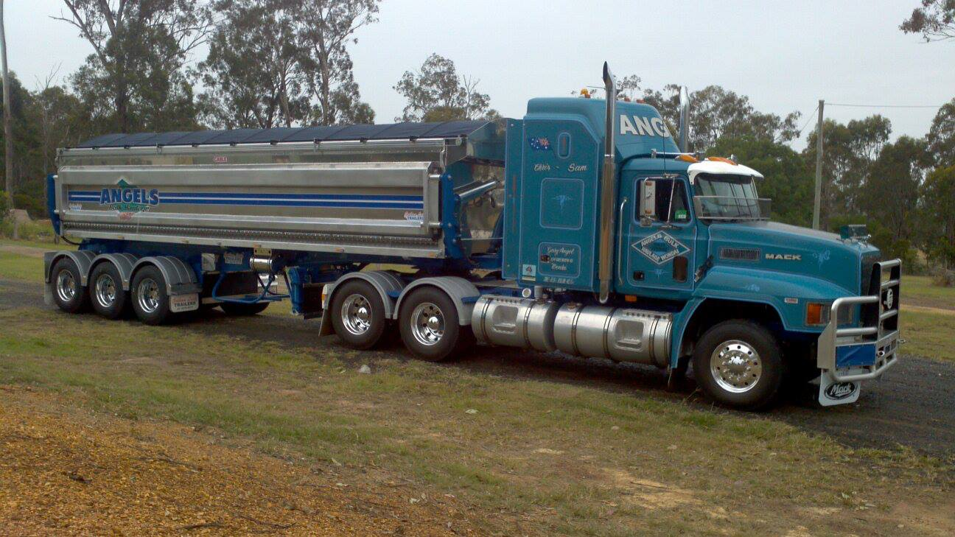
Class 1 Best Street Ute

Class 2 Best B & S Ute

Class 3 Best Chick’s Ute Registration papers required

Class 4 Best 4 x 4 Ute

Class 5 Best Work Ute

Class 6 Judges’ Choice

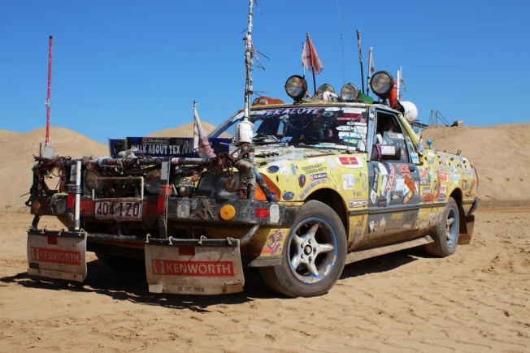
Class 7 Themed

Class 8 Most Colourful Display

SECTION 24

WESTLINK PETROLEUM TRUCK SHOW
2nd September 2023
9am for 9.30am judging

Trophies, Ribbons & Prize money to 3 places

Product/Vouchers to the same value may be substituted
for monetary prizes or vice versa
Prize money 1st $100, 2nd $75, 3rd $40

Class 1 …... Best 0—3 Years
Class 2 …… Best 4—9 Years
Class 3 …… Best 10—19 Years
Class 4 …… Best 20 –29 Years
Class 5 …… Best Vintage 30 + Years
Class 6 …… Best Local Rig (South Burnett Region)
Class 7 …… Best Fleet (3 or more)
Class 8 …… Best Lights
Class 9……. No Time for Shine
Class 10…… Best Bling
Class 11……. Best Tribute
Class 12……..People’s Choice

TRUCK OF THE SHOW $750
RUNNER UP $400
ENCOURAGEMENT AWARD $250

Sponsored by:- Westlink Petroleum, Country Trucker Caps, Parker Plumbing, Brown & Hurley, ND Fabrication, Harley Heavy Diesel, Gleich Trucks, Tranzmile Kingaroy

TRUCK SHOW & SHINE
ENTRY FORM
2nd September 2023
ENTRY FEE $15 per Truck. Each truck can enter up to 4 classes
Class 1 …... Best 0—3 Years
Class 2 …… Best 4—9 Years
Class 3 …… Best 10—19 Years
Class 4 …… Best 20—29 Years
Class 5 …… Best Vintage (30 + Years)
Class 6 …… Best Local Rig SB Area
Class 7 …… Best Fleet (3 or more)
Class 8 …… Best Lights
Class 9……. No Time for Shine
Class 10…… Best Bling
Class 11……. Best Tribute
Class 12……. People’s Choice
* TRUCK OF THE SHOW $750
♦ RUNNER UP $400
♦ ENCOURAGEMENT AWARD $250
Rego Number …………..……………..
Make ……………..………………….
Model …………………………. Year ……………..
Name:………………………………………….……
Phone:………………….. Email:……………………………
Address:……………………………………………..
Entry fee paid by 29th August by cheque or transfer
Cheques made out to Wondai A P & I Soc.
P O Box 159, Wondai 4606
Email secretary@wondaishow.com.au
BSB 633 000 Account Number 1593 52418
Reference—Last Name & ‘trucks’
FREE CAMPING FOR ENTRANTS ON SHOW GROUNDS FRIDAY & SATURDAY NIGHTS—UNPOWERED SITES ONLY GENERATORS ALLOWED

SHOW & SHINE
DETAILS TO BE RELEASED SHORTLY

