**Wondai Show 2nd September 2023**

**SECTION 5 – FARM PRODUCE – This section is sponsored by Unicorn Speciality Foods P/L WONDAI**

**CHIEF STEWARD: JOSH STEINHARDT**

**STEWARD: LAURIE MARTIN**

**CONDITIONS**

1. **Please note General Pavilion Regulations, (Points 3 - 6).**

2. All exhibits in this section to be grown in the State.

3. Sheaves to be not less than 40 cms in circumference; collections of sheaves to be 20 cms circumference.

4. Exhibits in collections of Farm Produce are not to compete in any other class. The same applies between individual classes.

5. Where a trophy or voucher is awarded, no prize money is given.

**ENTRY FEE: 50 cents per entry**

**PRIZE MONEY - 1st: $4.00 2nd: $2.00** (unless otherwise stated)

**SHELLED MAIZE: 2.0 kg minimum**

1. Any Pioneer variety

2. Any Pacific variety

3. Any other variety, named

**MAIZE: 3 COBS (dry)**

4. Any Pioneer variety

5. Any Pacific variety

6. Any other variety, named

**MAIZE: BUNDLE OF 3 STALKS WITH COBS** (leaves, husks, roots may be removed)

7. Any Pioneer variety

8. Any Pacific variety

9. Any other variety, named

**BEST MAIZE EXHIBIT: 20L Prolube Ultra Fleet donated by Lowes Petroleum**

**GRAIN SORGHUM SEED - 2 kg minimum**

10. Any Pioneer variety

11. Any Pacific variety

12. Any Nuseed variety

13. Any other variety, named

**GRAIN SORGHUM: heads on stalks, min 3 heads** (leaves & roots may be removed)

14. Any Pioneer variety

15. Any Pacific variety

16. Any Nuseed variety

17. Any other variety, named

**BEST SORGHUM EXHIBIT: 1 BAG SEED - donated by GENTECH SEEDS**

**PEANUTS IN SHELL: 1.5 kg minimum**

18. Red Spanish

19. White Spanish

20. Virginia Bunch

21. Any other variety, named

**PEANUT KERNELS: 1 kg minimum**

22. Red Spanish

23. White Spanish

24. Virginia Bunch

****25. Any other variety, named

**PEANUTS BUSH (dry)**

26. Red Spanish

27. White Spanish

28. Virginia Bunch

29. Any other variety, named

**SHEAVES: NOT NECESSARILY DRY** (to be judged on grain potential)

30. Wheat, any variety

31. Barley, any variety

32. Oats, any variety

33. Millet, any variety

34. Sunflower, 2 heads on stalks

35. Any other variety, named

36. Collection of Sheaves, named

**SHEAVES: GREEN** (to be judged on haymaking qualities)

37. Wheat

38. Barley

39. Oats

40. Forage Sorghum

41. Lucerne

42. Any other variety, named

**BEST GREEN SHEAF EXHIBIT: 20L Prolube Ultra Fleet donated by Lowes Petroleum**

**SEEDS**

43. Soya Beans, any variety

44. Sunflower (oilseed)

45. Sunflower (birdseed)

46. Navy Beans

47. Mung Beans

48. Millet, any variety

49. Rhodes (300g minimum)

50. Green Panic (300g minimum)

51. Any other variety, named

**BEST EXHIBIT CLASSES 43 – 51 $50 donated by UNICORN SPECIALTY FOODS P/L Wondai**

**GRAIN: 1.5 kg minimum**

52. Wheat, any variety

53. Barley, any variety

54. Oats, any variety

55. Any other variety, named

56. Collection, 3 minimum, named

**CHAFF: 5 kg minimum**

57. Lucerne

58. Oaten

59. Any other variety, named

**HAY: 1 bale**

60. Lucerne

61. Peanut

62. Any other variety, named

**PUMPKINS**

63. Queensland Blue, 2

64. Jarrahdale, 2

65. Jap, 2

66. Butternut, 2

67. Any other Table Pumpkin, named

68. Heaviest Pumpkin

69. Collection of Table Pumpkins, named

**MELONS**

70. Pie Melon

71. Citron Melon

**ROOT CROPS**

72. Onions, white, 3

73. Onions, brown, 3

74. Potatoes, Sebago, 2.5kg min. (judged on marketing ability)

75. Potatoes, Pontiac, 2.5kg min. (judged on marketing ability)

76. Potatoes, any other variety, 2.5kg min. (judged on marketing ability)

77. Potatoes, 3 largest

78. Potatoes, sweet white

79. Potatoes, sweet red

80. Potatoes, any other variety, named

**EXHIBITOR MOST POINTS FARM PRODUCE**

**$50 voucher from Unicorn Specialty Foods**



**Wondai Show 2nd September 2023**

**SECTION 6 – FRUIT & VEGETABLES**

**CHIEF STEWARD: RAY ZISCHKE - Ph: 4168 9848**

**STEWARD: Joyce Zischke**

**CONDITIONS**

1. **Please note General Pavilion Regulations , especially regarding entry procedures (Points 3 - 6).**

2. All exhibits to be grown in Qld by the exhibitor (unless otherwise stated)

**ENTRY FEE: 50 cents per entry**

**PRIZE MONEY - 1st: $4.00 2nd : $2.00** (unless otherwise stated)

**EGGS**

1.  Hen Eggs: Tinted, 6

2.  Hen Eggs: White, 6

3.  Hen Eggs, Brown, 6

(Classes 1-3 judged on the best marketing quality)

4.  Bantam Eggs. 6

5.  Heaviest Eggs, 6 – **1st $5, 2nd $4, 3rd $3.**

6. Any other eggs not mentioned.

**HONEY**

7.  Honey, any variety, 2 jars

**FRUIT**

8. Tangelo, 3

9. Oranges, 3

10.  Oranges, Navel, 3

11. Mandarins, 3

12. Lemon, Meyer, 3

13. Lemon, Lisbon, 3

14. Lemon, Bush, 3

15. Lemonade, 3

16. Lemon, any other variety, 3, named

17. Limes, 3

18. Grapefruit, 3

19. Citrons, 3

20. Collection of citrus fruits, named

21. Custard apples, 3

22. Pawpaws, 3

23. Passionfruit, 3

24. Avocado pears, 3

25. Strawberries, plate

26. Loquats, 1 dozen

27.  Fruit, any other variety (named)

**BEST EXHIBIT FRUIT (Classes 8 - 27)**

**PRIZE donated by JOYCE ZISCHKE**

**EXHIBITOR GAINING MOST POINTS IN FRUIT CLASSES (8-27)**

**OSCAR JARVIS MEMORIAL TROPHY donated by ELSIE KNIGHT**

**NUTS**

28. Queensland/Macadamia nuts, 1 dozen

29. Pecan nuts, 1 dozen

**VEGETABLES**

30. Tomatoes, red, 3

31.  Tomatoes, egg shaped, 4

32.  Eschallots, single bunch

33.  Silver Beet, bunch

34.  Celery, bunch

35.  Cauliflower, 1

36. Cabbage, Sugar Loaf, 1

37.  Cabbage, Flat Head, 1

38.  Cabbage, any other variety, 1

39. Cabbage, Heaviest, 1

40. Lettuce, Mignonette, 1

41.  Lettuce, Lakes, 1

42. Lettuce, any other variety, 1

43.  Turnips, any variety, 3

44. Beetroot, 4

45. Radishes, long, 6

46. Radishes, round, 6

47. Rhubarb, bunch

48. Broccoli, 1 plate

****49. Peas in Pod, 1 plate

50. Carrots, short, 4

51. Carrots, long, 4

52. Leeks, bunch

53. Snow peas, 1 plate

54. Bok Choy

55. Any vegetable not specified, (named)

56. Collection of vegetables, (named)

57. Collection of Green Herbs, (named)

58 Any unusual fruit or vegetable (named)

**BEST EXHIBIT VEGETABLES**

**PRIZE DONATED BY RAY ZISCHKE**

**EXHIBITOR GAINING MOST POINTS IN VEGETABLES CLASSES**

**TROPHY donated by JOYCE ZISCHKE**

**JUNIOR DIVISION (17 years and under) - FREE ENTRY Prize Money - 1st: $4.00; 2nd: $2.00, 3rd $1**

**Points in this Division** (1st - 2 points; 2nd - 1 point) **count towards the Barbeques Galore Trophy**

59. Beetroot, 3 67. Oranges, 3

60. Table Pumpkin, 1 68. Mandarins, 3

61. Cabbage, 1 69. Lemons, 3

62. Lettuce, 1 70. Strawberries, 1 plate

63. Peas, 1 plate 71. Any other fruit, named

64. Carrots, 3 72. Hen Eggs, white or tinted, 6

65.  Radishes, 6 73. Hen Eggs, brown, 6

66.  Other veg, named 74. Bantam Eggs, 6

75. Best decorated Fruit or Vegetable

**BEST EXHIBIT JUNIOR DIVISION**

**PRIZE donated by DENISE STEINHARDT**

**C. JUNIOR (12 years and under)**

**FREE ENTRY PRIZE MONEY: 1st - $2.00 2nd - $1.00**

**Points in this Division (**1st - 2 points; 2nd - 1 point) **count towards the Barbeques Galore Trophy**

86.  Arrangement in a Shoe or Boot

87. Gent’s or Lady’s Buttonhole or Corsage

88.  Floral Saucer

89. Vase of Flowers arranged for effort.

90. Basket of Flowers

**D. JUNIOR (13 years to 17 years)**

**FREE ENTRY PRIZE MONEY: 1st - $2.00 2nd - $1.00**

**Points in this Division (**1st - 2 points; 2nd - 1 point) **count towards the Barbeques Galore Trophy**

91.  Arrangement in a Shoe or Boot

92. Gent’s or Lady’s Buttonhole or Corsage

93.  Floral Saucer

94. Vase of Flowers arranged for effort.

95. Basket of Flowers

**BEST EXHIBIT JUNIOR DIVISON** - (Classes 85 – 88) **PRIZE donated by LYNETTE ADRIAANS**

**Wondai Show 2nd September 2023**

**SECTION 7 - FLORICULTURE**

**CHIEF STEWARD: LYNETTE ADRIAANS - Ph: 4168 2876**

**STEWARD: Denise Steinhardt**

**CONDITIONS**

1. **Please note General Pavilion Regulations, especially regarding entry procedures (Points 3 - 6).**

2. All exhibits in **Division 1** must be the property, for at least 6 months, of the exhibitor, unless otherwise

stated, and must be the work of 1 person only.

3. Every **pot plant** must be established in the pot or box in which it is shown.

4. Exhibits in single classes are not eligible in collections.

5. Green bottles are preferred for displaying exhibits.

**ENTRY FEE: 50 cents per entry**

**PRIZE MONEY: 1st - $4.00 2nd - $2.00** (*unless otherwise stated)*



**DIVISION 1: PLANTS IN POTS**

1.  Palm

2. Maidenhair

3.  Fern, any other variety

4.  Cacti or Succulent

5.  Pot Plant in flower

6.  Begonia

7.  Collection of 3 Pot Plants

8. Plant, 1 pot, any variety

9. African Violet, 1 pot

10. Orchid— **Trophy donated by SOUTH BURNETT ORCHID CLUB**

11.  Foliage Pot Plant

12.  Hanging Basket, Fern or other than Fern

13. Bromeliad

**BEST EXHIBIT IN POTS (EXCLUDES ORCHIDS)**

**$25 VOUCHER donated by DIMITIES COTTAGE**

**DIVISION 2: CUT FLOWERS**

14. Stocks, 3 cuts, same colour

15. Stocks, 3cuts, different colours

16. Collection of Stocks

17. Leptospermum

18. Geraldton Wax

19. Statice, annual

20. Statice, perennial

21. Snapdragons, 3 spikes, same colour

22. Snapdragons, 3 spikes, different colours

23. Collection of Snapdragons

24. Iris, 1 cut

25. Any other Bulb type flower

26. Sweet Peas, 4 cuts, same colour

27. Sweet Peas, 4 cuts, different colours

28. Collection of Sweet Peas

29. Collection of Dwarf Sweet Peas

30. Nemesias

31. Poppies, any variety

32. Mini Rose, 1 cut

33. Rose, any colour, 1 bloom

34. Violas

35. Violets

36. Pansies, 3 different colours

37. Pansies, 6 different colours

38. Pansies, 12, not all need to be different

39. Flowering Vine, 1 stem

40. Flowering Natives, 3 stems, each different

41. Foliage shrub with/without berries, 1 stem

42. Flowering shrub, 3 stem, each different

43. Gladiolus, 1 bloom

44. Arum Lily, 1 bloom

45. Carnation, 1 bloom

46. Carnations, 3 blooms, different colours

47. Phlox

48. Larkspurs

49. Gerberas, single, 3 different colours

50. Gerberas, double, 3 different colours

51. Collection of Gerberas

52. Collection of Hybrid Gerberas

53. Candytuft

54. Ranunculus

55. Camellia, 1 bloom

56. Daffodil, 1 bloom

57. Collection of Daisies, mixed

58. Anemones

59. Calendulas, orange tones, 3 blooms

60. Calendulas, lemon tones, 3 blooms

61. Collection of Calendulas

62. Collection of Petunias, singles

63. Collection of Petunias, double

64. Geranium, single, 1 cut

65. Geranium, semi double, 1 cut

66. Geranium, double, 1 cut

67. Geranium, ivy, 1 cut

68. Collection of Geraniums

69. Pelargoniums, 1 spike

70. Freesias

71. Nasturtiums

72. Flower, unspecified to be named

73. Collection of cut flowers

**EXHIBITOR MOST POINTS DIVISION 1 & 2 - PRIZE donated by WONDAI AND DISTRICT GARDEN CLUB**

**CHAMPION BLOOM OF SHOW - $20 PRIZE donated by WONDAI AND DISTRICT GARDEN CLUB**

**DIVISION 3: DECORATIVE WORK**

**Flowers need not be grown by exhibitor. Any greenery and accessories may be used.**

**ENTRY: 50 CENTS PER ENTRY**

**PRIZE MONEY: 1ST - $5.00 2ND - $3.00**

**A. OPEN**

74. Arrangement depicting a Song (to be named)

75. Arrangement for a Silver or Golden Wedding

76. Arrangement of Flowers ‘ One Colour Only’.

77. Miniature arrangement, not more than 10cms in height

78. Arrangement of Australian Natives (flowers and foliage)

79. Making the most of one Flower

80. Arrangement of Lavender and Lace

**B. NOVICE** (open to anyone who has not won a prize at a Show in Decorative Classes; exhibitors can only enter in these classes for 2 years)

81. Arrangement using Kitchen Utensil

82. Basket of Flowers

83. Arrangement using 3 Flowers and 3 Leaves only.

84. Arrangement of flowers in 2 colours (foliage may be used)

85. Arrangement for Table Centre

**CHAMPION EXHIBIT DECORATIVE WORK - $20 PRIZE donated by WONDAI AND DISTRICT GARDEN CLUB**

**C. JUNIOR (12 years and under)**

**FREE ENTRY PRIZE MONEY: 1st - $2.00 2nd - $1.00**

**Points in this Division (**1st - 2 points; 2nd - 1 point) **count towards the Barbeques Galore Trophy**

86.  Arrangement in a Shoe or Boot

87. Gent’s or Lady’s Buttonhole or Corsage

88.  Floral Saucer

89. Vase of Flowers arranged for effort.

90. Basket of Flowers

**D. JUNIOR (13 years to 17 years)**

**FREE ENTRY PRIZE MONEY: 1st - $2.00 2nd - $1.00**

**Points in this Division (**1st - 2 points; 2nd - 1 point) **count towards the Barbeques Galore Trophy**

91.  Arrangement in a Shoe or Boot

92. Gent’s or Lady’s Buttonhole or Corsage

93.  Floral Saucer

94. Vase of Flowers arranged for effort.

95. Basket of Flowers

**BEST EXHIBIT JUNIOR DIVISON** - (Classes 85 – 88) **PRIZE donated by LYNETTE ADRIAANS**

**Wondai Show 2nd September 2023**

**CHIEF STEWARD: Del Blanch 0428 689 329**

**STEWARDS: Leonie Evans, Delma Robbins, Ann Kerkow, Maree Klibbe**

**CONDITIONS**

1.  **Please note General Pavilion Regulations especially regarding entry procedures (Points 3 - 6).**

2. White paper plates, or white cardboard plates to be used for displaying exhibits.

3. Only one entry per exhibitor in any class.

4. No packet mixture permitted unless otherwise stated.

**ENTRY FEE: 50 CENTS PER ENTRY**

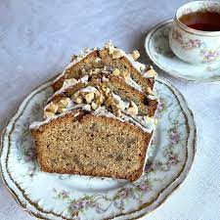**PRIZE MONEY - 1ST: $4.00 2ND: $2.00** (*unless otherwise stated) .***.**

**SECTION 8A**

**DIVISION A**

1. Scones, Plain, 6

2. Scones, Sweet 6

3. Scones, Pumpkin, 6

4. Pikelets, 6

5. Butter Sponge Sandwich, egg & sugar mixture, jam filling

6. Peach Blossom Cake, bar tin, iced on top only.

7. Marble Cake, round tin, pink icing, top only

8. Orange Bar Cake, iced, top only

9. Kentish Cake, bar tin, coconut, sultanas, cherries, walnuts, iced on top, chocolate icing sprinkled with crushed nuts or coconut **– 1st Prize $10, 2nd Prize $5 donated by Joyce Zischke**

10. Feature Cake - Ginger Bread Cake – recipe supplied.

**Mrs AV Smith Memorial 1st prize $10 donated by Beryl Smith. 2nd $5 3rd $2.50**

11. Health Cake, to be named (bar tin)

12. Date Loaf, dark, (bar tin)

13. Cake, any other variety, to be named

14. Cup Cakes, plate of 6, iced, cooked in tins

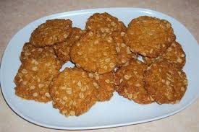15. Raspberry Slice, plate of 6

16. Slice, any other variety, plate of 6, to be named

17. Muffins, fruit, plate of 6, to be named, no papers

18. Ginger Biscuits or Ginger Nuts, plate of 6

19. Coconut Biscuits, plate of 6

20. Anzac biscuits, Plate of 6

**BEST EXHIBIT DIVISION A $25 donated by Joyce Sefton**

**DIVISION B: ALLERGY FREE**

21. Gluten Free Cake – Packet cake front to be provided

22. Gluten Free Slice, plate of 6 - to be named

 **DIVISION C: MALE COOKS OPEN**

23. Packet Cake – front of packet to be provided.

**First Prize $5 donated by Leonie Evans**

**DIVISION D: FRUIT CAKES**

24. Rich Fruit Cake, 250g mixture including whole currants, cut raisins , sultanas, cut mixed

peel & cherries. Baked in tin not exceeding 20cm square.

**MRS B ISZLAUB MEMORIAL PRIZE 1st: $10.00; 2nd: $5.00**

**Highest S B placegetter eligible to enter 2024 SB Subchamber Rich Fruit Cake competition.**

25. Boiled Fruit Cake, using 375g mixed fruit **1st $12, 2nd $8, 3rd $5 donated by Joyce Sefton**

26. Pumpkin Fruit Cake, round tin

27. Sultana Bar

28. Date Pudding, steamed in basin

**DIVISION E: CONFECTIONARY**

(Small paper plates to be used)

29. Coconut Ice, plate of 6

30. Chocolate Fudge, plate of 6

31. Marshmallows, plate of 6

32 Confectionary, any variety to be named, plate of 6

**BEST EXHIBIT DIVISIONS B, C, D & E Trophy donated by Dimities Cottage**

**CHAMPION EXHIBIT CULINARY CLASSES 1—32**

**$50 DONATED BY OUR PATRON JOYCE SEFTON**

**DIVISION F: JUNIOR DIVISION - FREE ENTRY PRIZE MONEY: 1st - $4.00 2nd - $2.00**

**Points in this Division** (1st - 2 pts; 2nd - 1 pt) **count towards Barbeques Galore Trophy**

**PRIMARY STUDENTS AGES 12 YEARS & UNDER**

***(small paper plates only to be used for classes 33 & 34)***

33. Arrowroot biscuits, 3 iced & decorated ( **age 4 -5 years**)

34. Decorated Cup Cakes 4 iced (**age 6 – 8 years**) ***judged on decoration only***

**Ages 12 & Under**

35. Sweet Scones, plate of 4

36. Cornflake Biscuits, plate of 4

37. Anzac Biscuits, plate of 4

38. Pikelets, plate of 4

39. Chocolate Bar Cake - iced on top only

40. Packet Cake, Sultana Bar –front of packet to be included

41. Coconut Delight (recipe supplied)

**MOST POINTS PRIMARY STUDENTS - $10.00 donated by EILEEN BEER**

**ENCOURAGEMENT AWARD PRIMARY $5.00 donated by EILEEN BEER**

**SECONDARY STUDENTS (ages 13 – 15 years)**

42. Plain Scones, plate of 4

43.  Cup Cakes, plate of 4, papers removed, plain icing, no decoration

44.  Pikelets, plate of 4

45.  Muffins, plate of 4 named, no papers

46.  Chocolate Bar Cake iced on top

47. Chocolate Slice, iced on top, plate of 4 pieces

48. Packet Slice. Made as per packet, plate of 4 pieces, label to be included

49. Peanut Biscuits, plate of 4

50. Milo Biscuits, plate of 4 recipe supplied

**MOST POINTS AGES 13 – 15 YEARS - Trophy donated by LEONIE EVANS**

**ENCOURAGEMENT AWARD SECONDARY CLASSES 42 – 50 - $5 donated by EILEEN BEER**

**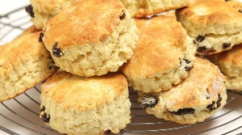 AGES 16 – 17 YEARS**

51. Boiled Fruit Cake using 375g Mixed Fruit

52. Jam Drops, plate of 4

53. Muffins to be named, plate of 4 No papers

54. Sultana scones, plate of 4

55. Fruit Slice, plate of 4 pieces recipe supplied

**MOST POINTS AGES 16 – 17 YEARS** **$10 donated by EILEEN BEER**

**CH EXHIBIT JUNIOR DIVISION – classes 33 - 55 - PRIZE donated by NORMA ISZLAUB**

**ENCOURAGEMENT AWARD - TROPHY DONATED BY DEL BLANCH**

**CULINARY SECTION 8B DECORATED CAKES**

Chief Steward: Gloria Berry – Ph 0437 774 238

Assist Steward: Sandy Taylor Ph 0422 975 559

Entry Fee $1.00 Entries close 9am Friday 1st September 2023

Sponsored by South Burnett Cake Decorators, Wondai Show Society, Gloria Berry & Leonie Evans

Conditions: 1. Cake dummies may be used for all classes except Sugar Craft 2. Fondant covering to be used for iced cakes 3. No artificial flowers, leaves or other decorations. Ribbons allowed

**Class 56 Special Occasion Cake**

Iced with Fondant & bearing an inscription. Own Choice. Exhibitor’s work only

1st $20 – donated by South Burnett Cake Decorators; 2nd $15; 3rd - $10

**Class 57 Novelty Cake**

Exhibitor’s own design choice. Fondant covered & decorated

1st $20 – donated by South Burnett Cake Decorators; 2nd $15; 3rd - $10

**Class 58 Miniature Cake**

Exhibitor’s own design choice & shape. Must not exceed 4” (10 cm) with icing

1st $20 ; 2nd $15; 3rd - $10

**Class 59 Sugar Craft**

Exhibitor’s own choice. Must be presented on a Plaque or Fondant covered board.

1st $20 ; 2nd $15; 3rd - $10

**Class 60 One Tier Decorated Cake – Juniors aged 5 – 17 years**

Exhibitor’s own design on fondant covered board, fondant covering on cake. Sugar decorations must be the work of the exhibitor. No artificial flowers or leaves. Ribbon allowed

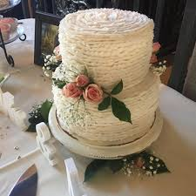1st $10 ; 2nd $8; 3rd - $6

**RECIPE FOR GINGER BREAD CAKE CLASS 10**

**Ingredients:** 1 cup sugar 1 cup milk

1 cup treacle 1 tab ground ginger

¾ cup butter 1 cup plain flour

3 eggs 1 dessert sp nutmeg

3 cups flour 2 teas soda

**Method:** Cream butter, add sugar & eggs, beat well then add treacle & milk mixing well. Add sifted flour & spices, and last add soda dissolved in a little hot water. Pour into a square tin, greased & lined and bake at 150°for 1 ½ hours or until cooked.

**RECIPE FOR COCONUT DELIGHT CLASS 41**

**Ingredients:** 5oz (140g) Butter/Marg 1 ½ cups SR flour

1 tab cocoa 1 cup crushed cornflakes

½ cup sugar 1 cup desiccated coconut

1 dessert spoon golden syrup ½ teaspoon vanilla

**Method:** Sift flour & cocoa, add cornflakes, sugar & coconut. Melt butter & syrup, add vanilla and blend into dry ingredients. Press into greased 8” x 12” tin (20 x 30cm) & cook until light brown. Ice with chocolate icing & cut into squares.

**RECIPE FOR MILO BISCUITS CLASS 50**

**Ingredients:** 4oz (125gr) butter 2 tabs Milo

1 small cup sugar 1 ¾ cup SR flour

1 egg ½ cup sultanas chopped

**Method:** Beat butter & sugar, then add egg & beat well. Add milo, flour & sultanas and mix well. Knead with hands until smooth ball forms. Break of pieces the size of a large marble, place on a greased tray and press out slightly with fork. Bake in a moderate oven for 10 minutes, or until golden.

**RECIPE FOR FRUIT SLICE CLASS 55**

**Ingredients:** ¼ lb (125gr) butter/marg ½ cup mixed fruit

1 egg well beaten 1 cup SR flour

¾ cup sugar ¾ cup coconut

Salt & vanilla

**Method:** Melt butter & fruit in saucepan. Place dry ingredients in bowl, add fruit & butter.

Stir in egg & vanilla. Spread in 7x11” (18x28cm) tray & bake in moderate oven for about20 – 25 mins until golden brown. Ice with lemon icing & cut into squares.

**Wondai Show 2nd September 2023**

**SECTION 9 – HOME PRESERVES**

**CHIEF STEWARD: ELSIE KNIGHT - Ph: 0428 446768**

**CONDITIONS**

1.  **Please note General Pavilion Regulations, especially regarding entry procedures (Points 3 - 6).**

2. All fruit and vegetables to be cut by hand.

3. All entries to be in **glass jars**, 250g in size & clearly labelled.

4. All bottles to have screw tops if possible.

5. Jars to be filled to just **under the rim**.

6. No single article to be entered in any two classes.

7. Where a single entry is received in any class, the judge may use their discretion to award a prize.

**ENTRY FEE: 50 cents per entry**

**PRIZE MONEY - 1st: $4.00 2nd: $2.00** (*unless otherwise stated)*

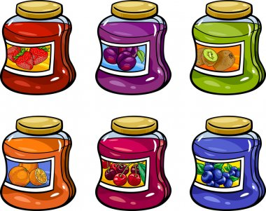**JAMS & JELLIES**

1. Tomato Jam

2. Fig Jam

3. Rosella Jam

4. Strawberry Jam

5. Passionfruit Butter

6. Lemon Cheese

7. Dried Peach Jam

8. Dried Apricot Jam

9. Pineapple Jam

10. Any other Jam, Jelly or Butter (named)

**MARMALADE**

11. Sweet Orange

12. Three Fruits

13. Any other Marmalade (named)

14. Collection of 6 x 200g jars - 2 Jam, 2 Butter, 2 Marmalade

**Trophy for Class 14 donated by Elsie Knight**

**SAUCES, PICKLES & CHUTNEYS**

15. Mango Chutney

16. Tomato Chutney or Relish

17. Mustard Pickles

18. Any other Sauce/Pickle/Chutney (named)

**EXHIBITOR MOST POINTS HOME PRESERVES Classes 1-18**

**PRIZE – donated by Wondai Show Society**

**Wondai Show 2ND SEPTEMBER 2023**

**SECTION 10 - NEEDLEWORK**

**CHIEF STEWARD: ROSLYN HANSEN - Ph: 0488 205 466**

**STEWARDS: GLENIS RADUNZ, KYLIE THOMPSON, FELICITY JORGENSEN, MARIAN BARNES, REBECCA REINKE**

**JUDGING FOR THIS SECTION WILL BE FRIDAY 1ST SEPTEMBER 2023**

**CONDITIONS:**

1. **Please note General Pavilion Regulations, especially regarding entry procedures (Points 3 - 6).**

2. If the judge considers an exhibit not of sufficient merit, no award is to be made.

3. All entries to be the bona fide work of the exhibitor.

4. Winning exhibits not to be re-entered for 2 years.

5. Exhibits may not be entered in more than one class.

6. Where a trophy or voucher is awarded, no prizemoney is given.

7. To determine ‘Most Points’: 1st - 2 points; 2nd - 1 point.

**ENTRY FEE: 50 cents per entry**

**PRIZE MONEY - 1st: $4.00; 2nd: $2.00** (un*less otherwise stated)*

**FANCY WORK AND SEWING**

**CLASSES 1, 2 , 4 – 9 First place $10 voucher sponsored by Somethings Country**

1. Hand Embroidery, article to be used (doily, cloth etc)
2. ****Hand Embroidery, decorative article (wall hanging)
3. Tapestry
4. Cross Stitch Article, no embellishment
5. Cross Stitch Article, with embellishment
6. Long Stitch Article
7. Check Gingham Article
8. Hand Applique, any Article
9. Machine Sewn Item - Not a garment
10. Machine Sewn Garment
11. Shopping Bag, any Style. Must be lined
12. Thrift. Something New from Something Old

**EXHIBITOR GAINING MOST POINTS CLASSES 1 –12 (Fancy Work/Sewing)**

**VOUCHER donated by WOOROOLIN FABRICS**

**KNITTING**

13. Infant’s Set – can include Matinee Jacket, Bonnet and Bootees or any two of the three

14. Garment – fine thread

15. Garment – heavy thread

16. Scarf – any size

17. Scarf – any yarn

18.Tea Cosy – Must be lined

19. Adult Cap or Beanie

20. Toy or Doll

21. Knee Rug knitted in Wool, no larger than 150cm x 150cm

**EXHIBITOR GAINING MOST POINTS CLASSES 13 –21 (Knitting)**

**VOUCHER donated by WOOROOLIN FABRICS**

**CROCHET**

22. Tea Cosy, must be lined

23.  Dressing Table Set, centre or runner

24.  Doily

25.  Article in Medallions, any cotton (not wool)

26. Article with Crochet Edge – edge only to be judged

27 Infant Set, can include Matinee Jacket, Bonnet & Bootees, or combination of any two

28. Jacket – Adult or Child – must be specified

29. Shawl Baby or Adult

30. Knee Rug crochet in wool, no larger that 150cm x 150cm

31. Scarf

32. Jug Cover

33. Novelty Item

**EXHIBITOR GAINING MOST POINTS CLASSES 22 - 33 (Crochet)**

**VOUCHER donated by WOOROOLIN FABRICS**

**PATCHWORK**

**Classes 34 – 41 First place $10 voucher sponsored by Somethings Country**

34. Quilt, Hand Appliqued or Hand Quilted

35. Patchwork Quilt, Machine Sewn & Quilted, emphasis on the patchwork

36. Patchwork Quilt, can feature Machine Embroidery blocks or other embellished blocks.

37. Patchwork Cushion cover with insert.

38. Patchwork Wall Hanging with provision to hang.

39. Patchwork Runner or Place Mat

40. Patchwork Bag

41. Crazy Patch Article

**EXHIBITOR GAINING MOST POINTS CLASSES 34 - 41 (Patchwork)**

**VOUCHER donated by WOOROOLIN FABRICS**

**JUNIOR DIVISION - FREE ENTRY**

**PRIZE MONEY: 1st: $4.00; 2nd: $2.00**

**Points in this Division** (1st - 2 points; 2nd - 1 point) **count towards the Barbeques Galore Trophy** (See page 48 of Schedule for details)



**SECTION A 12 YEARS AND UNDER**

42. Crochet Article

43. Knitted Article

44. Hand Embroidery

45. Patchwork Article

46. Machine Sewn Article

47. Cross Stitch Article

**BEST EXHIBIT JUNIOR DIVISION 12 YEARS AND UNDER (Classes 42 – 47)**

**VOUCHER donated by WOOROOLIN FABRICS**

**ENCOURAGEMENT AWARD 12 YEARS AND UNDER CLASSES 42 – 47**

**donated by WOOROOLIN FABRICS**

**SECTION B 13YEARS TO 17 YEARS**

48. Crochet Article

49. Knitted Article

50. Hand Embroidery

51. Patchwork Article

52. Machine Sewn Article

53 Cross Stitch Article

.

**BEST EXHIBIT JUNIOR DIVISION 13 - 17 YEARS (Classes 48 -53)**

**PRIZE donated by WOOROOLIN FABRICS**

**ENCOURAGEMENT AWARD donated by WOOROOLIN FABRICS**

**Wondai Show 2nd September 2023**

**SECTION 11 - HANDCRAFT**

**CHIEF STEWARD: Fay Kerkow 0458 660 060**

**STEWARDS: Monica Dehnert**

**JUDGING FOR THIS SECTION WILL BE FRIDAY 1st September 2023**

**CONDITIONS:**

1. **Please note General Pavilion Regulations, especially regarding entry procedures (Points 3 - 6).**

2. If the judge considers an exhibit not of sufficient merit, no award is to be made.

3. All entries to be the bona fide work of the exhibitor.

4. Winning exhibits not to be re-entered for 2 years.

5. Exhibits may not be entered in more than one class.

6. Where a trophy or voucher is awarded, no prizemoney is given.

7. To determine ‘Most Points’ : 1st - 2 points; 2nd - 1 point.

8. Scrapbooking pages to be in plastic sleeves for display.

**ENTRY FEE: 50 cents per entry**

**PRIZE MONEY - 1st: $4.00; 2nd: $2.00** (un*less otherwise stated)*

**OPEN DIVISION**

1. Diamond Art, full article

2.  Diamond Art, Partial art on article

3.  Jewellery, Necklace or Bracelet

4.  Jewellery, Pair of Earrings

5.  Card, handmade

6. Card, embroidery

7.  Card, celebration

8. Birthday Card, set of 3

9.  Any Article of quilling

10 Any Article of Paper Tole

**EXHIBITOR GAINING MOST POINTS CLASSES 1 –10**

**$15 voucher donated by GOOMERI EMPORIUM**

11. Wood burning 12. Mosaic

13. Folk or Decorative Art 14. Decoupage

15. Shopping Bag or Basket

16. Any Article Fabric Painting

17. Teddy Bear 18 Glass Painting

19. Pottery 20. Fridge Magnet

21. Scrapbooking Double page Children

22. Scrapbooking Double page Special occasion

23. Scrapbooking Single page Christmas

24. Scrapbooking Single page General

**EXHIBITOR GAINING MOST POINTS CLASSES 11 –24**

**$15 voucher donated by GOOMERI EMPORIUM**

25. Leather work, any article

26.  Picture. Any material

27.  Recycled, something new from something old

28.  Assortment of Christmas decorations, 3 distinct types

29. Handcraft, any other, named

30. Exhibitor over 70 years, any article

**EXHIBITOR GAINING MOST POINTS CLASSES 25 - 30**

**$15 voucher donated by GOOMERI EMPORIUM**

**NOVICE DIVISION:** open to anyone who has not won a 1st prize in Handcrafts

31. Toy, any material

32. Folk Art, any article

33. Card, handmade

34. Cushion

35. Coat Hanger, any material

36. Paper Tole, any article

37. Birthday Card

38. Assortment of Christmas decorations, 3 distinct types

39. Handcraft, any other, named

**EXHIBITOR GAINING MOST POINTS CLASSES 31 - 39**

**$15 voucher donated by GOOMERI EMPORIUM**

**OVERALL CHAMPION CLASSES 1 – 39**

**Trophy donated by Dell Blanch**

**JUNIOR DIVISION - FREE ENTRY**

**PRIZE MONEY: 1st: $4.00; 2nd: $2.00**

**Points in this Division** (1st - 2 points; 2nd - 1 point) **count towards the Barbeques Galore Trophy**

**13 – 17 YEARS**

40. Christmas decoration

41. Toy, any fabric

42. Card, handmade

43. Card, stamped

44. Card, computer generated

45. Scrapbooking, double page, any theme

46. Scrapbooking, single page, any theme

47. Diamond Art

48. Folk art, any article

49 Jewellery, necklace to be placed in small plastic bags

50. Decoupage

51. Any other handcraft, named

**EXHIBITOR GAINING MOST POINTS CLASSES 40 - 51**

**$15 voucher donated by GOOMERI EMPORIUM**

**OVERALL CHAMPION CLASSES 41 - 50**

**Trophy donated by FAY KERKOW**

**12 YEARS AND UNDER**

52. Christmas decoration

53 Toy, any fabric

54. Card, handmade

55. Card, stamped

56. Card, computer generated

57. Scrapbooking, single page, any theme

58. Jewellery, any article to be placed in small plastic bags

59. Folk Art, any article

60. Macrame

61. Any other handcraft, named

62. Diamond Art

**EXHIBITOR GAINING MOST POINTS CLASSES 52 - 62**

**$15 voucher donated by GOOMERI EMPORIUM**

**OVERALL CHAMPION CLASSES 52 - 62**

**Trophy donated by FAY KERKOW**



**SECTION 12 GROUP DISPLAY**

**OPEN TO ALL QCWA OR HANDCRAFT GROUPS AND CLUBS**

**CHIEF STEWARD: Janet Morris Phone 4168 5394**

**CONDITIONS**

1. Entry Forms must be in the hands of the Show Secretary by Friday 29TH August 2023 to reserve display space.

2. All displays to be completed by 9 am Friday, 1st Septeber 2023 ready for judging.

3. Display to be not less than 15 items and not more than 20 items.

**ENTRY FEE: $1.00 PRIZE MONEY: 1ST: $10; 2ND: $6.00; 3RD: $4.00**

**GENERAL RULES**

Colour scheme/theme to be chosen by group. Each article of work must be labelled. Only one article of work for each class. No article to have been entered in this Section at any previous show. Points awarded for number of individual articles, numbers of persons contributing, general display and labelling. Group/Club name may be added after judging.

**Wondai Show 2nd September 2023**

**SECTION 13 – PHOTOGRAPHY**

**CHIEF STEWARD: AMANDA STEVENS Ph: 0448 356 029**

**Judging to take place Friday 1st September 2023**

**CONDITIONS:**

* All exhibits must be the work of the exhibitor. Photographs may be commercially processed.
* All prints must be mounted on black cardboard (not thick). If NOT, then the Chief Steward reserves the right to staple image to cardboard.
* **General photos** - 12cms x 17cms (5x7 inches) with margins of 2½ cms/1 inch
* **Enlargements** - 8” x 12” (20cm x 30cm) size with margins of 4cms/1½ inches.
* **If not size stated photos will not be displayed**
* **NOVICE CLASS – No photo may be photo shopped in any way. No light changes or adding or removing objects. Cropping allowed.**
* Prints previously awarded 1st Prize at a Wondai Show are ineligible to compete in Novice section
* Exhibitors name is NOT to appear on the face of the exhibit. Reverse side of the exhibit must contain the following details : **A) Exhibitor’s name,B) Full address, C) Class no. entered, D) Phone number**
* If the Judge considers an exhibit not of sufficient merit no award will be made.
* Where prize/voucher is awarded, no prize money is given.
* To determine ‘Most Points’: 1st 2 point, 2nd 1 point
* **Entries close to close** 12 noon Friday, 25th August 2023 **and may be left at Wondai Regional Art Gallery between 21st & 25th August, posted to the Show Secretary (PO Box 159, Wondai 4606) or dropped off at the Show Office.**
* **All entries to be collected from the Pavilion after 4pm on Show Day, 2nd September**

**ENTRY FEE: 50 CENTS PER ENTRY**

**PRIZE MONEY - 1st: $4.00; 2nd: $2.00** (*unless otherwise stated)*

**DIVISION A - OPEN (for AMATEUR PHOTOGRAPHERS - who do not derive income from their photography)**

**Classes are for digitally unaltered photos unless otherwise stated.**

**1**. Water (in nature) **6**. Fur, flight, reptile & Aquatic

**2**. Nature a Frame within a Frame **7**. Portrait

**3**. Sunrise or Sunset **8**. South Burnett - Historic

**4**. Gardens **9**. Broken

**5**. Action **10**. Macro

**11**. Five O’Clock Somewhere (People’s Choice)

**ENLARGEMENTS**

**12**. People

**13**. Other

**CHAMPION PRINT—DIVISION A Classes 1 - 13**

**TROPHY donated by WONDAI PHARMACY**

**The following class is for fantasy/digitally altered photos unless otherwise stated**

**The original photo as well as the altered photo need to be shown.**



**14**. Subject of own choosing

**MOST POINTS DIVISION A (Classes 1 - 14) TROPHY donated by WONDAI PHARMACY**

**The following class is for ADVANCED PHOTOGRAPHERS – who derive income from their photography; photos that have won a 1st prize in the Open Division may also be entered in this Class .**

**15**. Three (3) related photos (eg different stages or angles) - subject of own choosing; fantasy/digitally altered photos are allowable. The 3 photos are to be mounted on one backing sheet.

**16**. Black & White Film

**ENLARGEMENTS**

**17**. Portrait/Wedding **18**. Nature

**1st: $10.00; 2nd: $5.00; 3rd: $2.00**

**DIVISION B: JUNIORS (A)12 years and under) or (B) 11 to 17 yrs - FREE ENTRY**

**Photos are to be digitally unaltered .**

**Points in this Division** (1st - 2 points; 2nd - 1 point) **count towards the Barbeques Galore Trophy**

**19**. Fur, flight, reptile & aquatic

**20**. People at work

**21**. Blue

**BEST EXHIBIT JUNIOR DIVISION**

**TROPHY donated by WONDAI PHARMACY**



**Wondai Show 2nd September 2023**

**SECTION 14 – FINE ARTS**

**CHIEF STEWARD: CASEY DAVIE**

**CONDITIONS**

1. All work must be true bona fide work of the exhibitor and less than 2 years old. Exhibits having previously won a prize at a Wondai Show may not compete.

2. Exhibits may be collected after 4.00 pm Saturday 2nd September 2023, under Steward’s supervision.

3. All paintings to be suitably framed and wired for hanging. Drawings should be framed where possible, or mounted attractively.

4. If the Judge considers an exhibit not of sufficient merit no award will be made.

5. Where a prize/voucher is awarded no prize money will be given.

6. **ENTRIES CLOSE 12.00 NOON MONDAY 28th AUGUST 2023. No late entries will be accepted.**

7. **Entries may be left at the Wondai Regional Art Gallery or the Show Office**

**OPEN DIVISION**

**ENTRY FEE: 60 cents per entry**

**PRIZE MONEY - 1st: $5.00; 2nd: $2.00**

1.  Landscape, any medium

2. Animal or Bird wildlife, any medium

3.  Portraits and Figures, any medium

4.  Water scene (coastal or inland), any medium

5.  Abstract, any medium

6. Still Life, any medium

7. Pottery, wheel or hand built

8. Ceramics & sculpture

**CHAMPION EXHIBIT OPEN DIVISION Classes 1 – 8**

**TROPHY donated by WONDAI REGIONAL ART GALLERY**

**JUNIOR DIVISION**

**FREE ENTRY PRIZE MONEY - 1st: $4.00; 2nd: $2.00**

**Points in this Division** (1st - 2 points; 2nd - 1 point) **count towards the Barbeques Galore Trophy**

9.  Pre-school to Grade 3—any medium, Poster A4 size

10. Grades 4—7, any medium, Poster A4 size

11.  Grades 8—10, any medium, Poster A4 size

**BEST EXHIBIT IN EACH CLASS 9 - 11**

**PRIZE donated by: WONDAI REGIONAL ART GALLERY**



**SECTION 15 COLLECTOR’S CORNER**

**Chief Steward: Brian Labudda 0400 625 366**

**Entry Fee $1.00 Prize Money: 1st $4.00 2nd $2.00 . Where trophy is awarded to winner, no prize money is awarded for 1st Prize**

**Conditions:**

· **All exhibits must be delivered to Stewards at the Showground**

* **Pavilion with entry cards attached, no later than 9am on Friday 1st September 2023**

· **Space allowed for each exhibit – one square metre.**

· **One exhibit per class**

· **Exhibits may not be entered in more than one class.**

· **Exhibits to remain displayed till 4pm show day, when Stewards will be in attendance for the removal of same.**

· **No responsibility will be taken for exhibits not collected by 4pm unless prior arrangement is made with the Steward or Secretary.**

· **Prize money will be available after 4pm show day .**

· **Judging will be by representatives of ‘Arms & Militia Press’**

· **Items will be judged on:**

**\*Rarity *Condition & Originality *Presentation Method**

**\*Correctness of Identification**

**Maximum 10 points for each**

**A $10 judge’s choice and an encouragement award will be awarded in both Open & Juvenile Sections.**

**1.** One Interesting or Unusual Tool

2.  4 Hat Pins

3.  Old Signs – One large or two small

4.  4 Die Cast Models – car, truck, tractor, motor bike or train (all one type or mixed)

5.  4 Cups & Saucers (Pairs or trios)

6.  4 Old Record Covers

7.  Unusual Ornament – any medium

8.  6 Australian Coins

9.  6 Collectors Cards

10.  4 Rocks, Minerals or Fossils ( all one type or mixed)

11.  2 Teapots

12.  4 Old Tins- Biscuit, Sweets, Tobacco etc .

(All one type or mixed)

13. 4 Frog Ornaments

14. 4 Horse Ornaments

15. 4 Salt & Pepper Sets

16. 6 Souvenir Teaspoons

17. Vintage Cards, Birthday, Poster etc 4 items

18. Collection of Old Buttons 6 items

19. Doll Collection 4 items (All one size or mixed)

20. Teddy Collection 4 items (All one size or mixed)

21. Militaria Collection 4 items

**Juvenile – entry free**

22. Dolls – Barbie or similar 2 items

23.  Toy Animals –small farmyard, zoo, dinosaur etc 6 items (All one type or mixed)

24. Australian Coins 4 items

25. Rocks, Minerals, Fossils 4 items ( All one type or mixed)

26. 6 Feathers

27. Small toys – Cars, Trucks, Trains, Tractors, Motorbikes etc. 4 items (All one type or mixed)

28. 4 Sea Shells.

**THIS SECTION SPONSORED BY WONDAI TRADERS**

**SECTION 16 - WOODCRAFT**

**CHIEF STEWARD: David Olm 0467 964 264**

**CONDITIONS**

1. **Please note General Pavilion Regulations ), especially regarding entry procedures (Points 3 - 6).**

2. If the judge considers an exhibit not of sufficient merit, no award made

****3. All entries to be the bona fide work of the exhibitor.

4. **NO ENTRY FEE** – Ribbons & place cards for 1st 2nd & 3rd.

5. No MDF (medium density fibreboard) accepted in any section.

**CLASSES**

1. Best turned bowl.
2. Best platter.
3. Best lidded item. Turned or unturned eg small lidded box
4. Best turned vase.
5. Best spindle turned item.
6. Carved article - relief
7. Carved article – in the round
8. Scroll or fretsaw work
9. Pyrography (must be on timber)

10.Wood combination with other medium.

11. Furniture item

12. Toys/models

13. Novelty item

14. Exhibit produced by Primary School student

15. Exhibit produced by Secondary School student

16. Best timber pen or pencil – 1 item per entry.

17. Veneered item (including marquetry or laminated).

**ENCOURAGEMENT AWARD**

**BEST JUVENILE EXHIBIT**

**BEST NOVICE EXHIBIT**

**REVERVE CHAMPION EXHIBIT**

**GRAND CHAMPION**

CLASS 1 Kindy to Year 2

Name…….………………………………………………………….

Year………..…………………………………………………………………..



**SECTION 17 COLOURING COMPETITION Celebrating 120 years of the Wondai Train Station**

SECTION 17 COLOURING IN

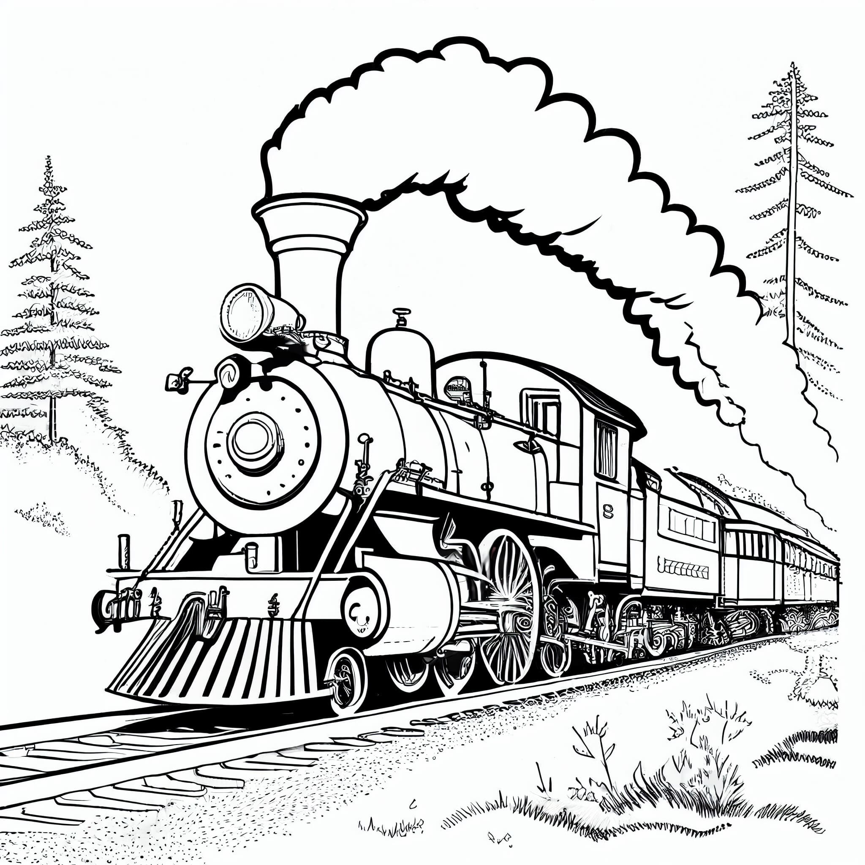

Wondai Show Sept 1st & 2nd 2023.

**Celebrating 120 years of the Wondai Train Station**

**CLASS 2 Year 3 – Year 6**

**Name ……………………………………………………………… Year …………………………………………….**

**SECTION 18 - LEGO/DUPLO**

**STEWARD: Felicity Jorgensen Ph: 0437 107 272**

**CONDITIONS**

1.  **Please note General Pavilion rules on page 50 especially regarding entry procedures (Points 3 - 6).**

2. Exhibitor’s age to be taken as of the 1st May in current year.

3**. The exhibit entered is to be an original design or creation & must not be a design or copy from instructions on boxes or sets.**

4. Exhibits **MUST** be on a solid base and no larger than 30cm x 60 cm

**ENTRY IS FREE**

**PRIZES IN THIS SECTION DONATED BY KINGAROY TOYWORLD**

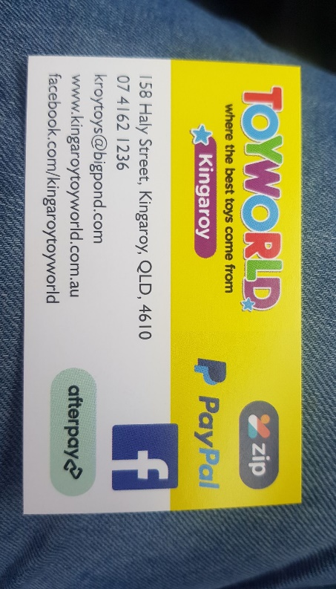

Judged on relevance to given theme, creativity, originality, design, skill and technique.

**Theme: 120 years since the Railway arrived in Wondai – can include historic railway or current use for the rail trail / station**

**1:** 6 years of age and under

**2:** 7 - 9 years of age

**3:** 10 - 12 years of age

**4:** 13 - 15 years of age

**5:** Open (16+ years of age)

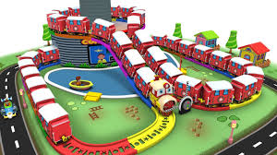



[Grab your reader’s attention with a great quote from the document or use this space to emphasize a key point. To place this text box anywhere on the page, just drag it.]

1st September. Winners will be contacted.

CHIEF STEWARD: DENNIS MORRIS

0427 685 394

Entry free

1st Prize $100, 2nd Prize $75 3rd Prize $50

Open to schools in Wondai, Tingoora, Crawford, Wooroolin, Wheatlands & Moffatdale

Theme for this year’s competition:- ‘120 Years of Passenger Rail in Wondai.’

Area of display approximately 3metres frontage.

Please let us know if your school is entering this section by 19th August to enable us to reserve enough space.

Colouring in competition.

Entry free Age groups Prep – Year 3, Year 4 to Year 6

Prizes to 3 places and posters will be used to advertise the show.

